**ASIAN COLLEGE OF HIGHER STUDIES**

**Tribhuvan University**

**Institute of Science and Technology**



**"LIBRARY MANAGEMENT SYSTEM"**

***In partial fulfillment of the requirement for the Bachelor Degree in Computer Science and Information Technology***

**"C Programming"**

**(CSC-110)**

**Submitted by**

**Adarsha Raj Acharya (16040/074)**

**Alok Aryal (16042/074)**

**Prabal Man Singh Basnyat (16064/074)**

**First Semester**

**Submitted to**

**Department of Computer Science and Information Technology**

**Asian College of Higher Studies**

**MAY, 2017**

**LETTER OF APPROVAL**

This is to certify that this project is prepared by three members of our group Aadarsha, Alok and Prabal entitled **“LIBRARY MANAGEMENT SYSTEM”** in partial fulfillment of the requirements for the degree of B.Sc. in Computer Science and Information Technology has been well studied. In our opinion it is satisfactory in the scope and quality as a project for the required degree.

**Internal Examiner:**

**Prarup Gurung**

**Lecturer**

**Bsc. Csit, Asian College of Higher Studies (ACHS)**

**ABSTRACT**

**Library Management System** is a project which aims in developing a computerized system to maintain all the daily work of library. This project has many features that can help the library in charge to keep the record digitally. It has also a facility where the staff of library after logging in the students accounts can see list of books issued and its issue date and return date and also the librarian can knew how much stocks of book of same publishers is available in the library. Moreover, the staff can know the exact location of book in the group of hundreds of book. Overall this project of ours is being developed to help the staff of library to maintain the library in the best way possible and also reduce the human efforts.

**ACKNOWLEDGEMENT**

It is always a pleasure to remind fine people in programming project works. The success and final outcome of this project required a lot of guidance and assistance from many people and we're extremely privileged to have got this all along the completion of my project. All that we have done is only due to such supervision and assistance and we would not forget to thank them.

Firstly, we're highly indebted to our C Programming Lecturer Prarup Gurung for his guidance and constant supervision as well as for providing necessary information regarding the project & also for his support in completing the project.

We're equally thankful to ACHS College and lab teacher for providing the internet for research and lab facilities that help in continuous testing of our codes and debug them in if necessary.

Many people, especially our classmates and team members itself, have made valuable comment suggestions on this proposal which gave us an inspiration to improve our assignment. We thank all the people for their help directly and indirectly to complete our assignment.

**TABLE OF CONTENTS**

|  |  |  |
| --- | --- | --- |
| **S.N.** | **Title** | **Page No.** |
| 1 | Introduction | 6 |
| 2 | Problem Analysis | 7 |
| 3 | Objective | 7 |
| 4 | Feasibility | 8 |
| 5 | Source Code | 8-38 |
| 6 | Testing | 39 |
| 7 | Implementation | 40 |
| 8 | Application Manual | 41-47 |
| 9 | Conclusion | 48 |
| 10 | References | 49 |

**MAIN PROJECT**

1. **Introduction:**

C is a powerful general-purpose programming language. It is fast, portable and available in all platforms. Library Management System is a project or a software which includes addition and removal of the books in a library to keeping new records of the book. From application of general printing of the statement to file handling in C we are going to create a tool for it. We've placed the roper comment for better understanding of the code. Similarly, other parts of C such as functions, structures, variable declaration, memory allocation, pointer, etc. which have helped a lot in making effective tool for library management system. As C is run in a compiler, the codes are run way much faster than other language. Although the code is large the compiling time is much lesser comparatively.

The first semester of Csit course only covers C programming so that is the main reason behind choosing this language but the easiness of C language also force us to choose this programming language. The other language requires a lot of libraries to run such code. Here, we're building the LMS for five faculties that exists in our college i.e. Bsc.Csit , BBA, B.IT, BBS, B.HM and B.Ed. respectively.

1. **Problem Analysis:**

In C programming, program analysis is the process of automatically analyzing the behavior of program regarding a property such as correctness, robustness, safety and liveness. Program analysis focuses on two major areas: program optimization and program correctness. In C, Program analysis can be performed without executing the program ([static program analysis](https://en.wikipedia.org/wiki/Static_program_analysis)), during runtime ([dynamic program analysis](https://en.wikipedia.org/wiki/Dynamic_program_analysis)) or in a combination of both.

Here are some steps we've taken in analyzing the problem in C:

1. Reviewing the problem carefully and understanding what we are asked to do.

2. Determining what inputs can be given by user and display output accordingly.

3. Assigning the separate name to each variable used.

4. Determining the processing manner especially in case of memory allocation during the run time, file handling and formulas needed to manipulate the give data.

1. **Objectives:**

We've choose LMS (Library Management System) as a C project because we feel the strong need of this system in every colleges and schools. We're planning to build the certain entity within the system which objectify as follows:

1. To build the system to classify the book faculty wise.
2. To make easiness to enter and remove the new books in library.
3. To keep the record of complete information of a book like; Book name, Author name, Publisher’s name, Date/ Year of publication, Cost of the book, Book purchasing date/ Bill no.
4. To search the availability of the books in case of necessity.
5. To make check-in and check-out easily.
6. **Feasibility Study:**

Feasibility is the study of impact, which happens in the organization by the development of Library Management System. And for the system to be act as worth-while it should passed through some analysis and here we're going to discuss about technical and economic feasibility:

1. Technical Feasibility:

We can strongly say that is technically feasible, since there will be not much difficulty in getting required resources for the development and maintaining the system as well. All the resources needed for the development of the system is available in the organization.

1. Economic Feasibility:

Development of Library Management System is highly economically feasible. The college need not spend much more for the development of the system already available. The only thing is to be done is making an environment for the development with and effective supervision and we're very grateful that we got it from our lecturer. Even after the development of the system, the college shouldn't invest more in. Therefore, the system is economically feasible.

1. **Source Code:**

Obviously the main part of this system is the source code which should be run to make the system work properly, which is presented as below:

#include<windows.h>

#include<stdio.h>

#include<conio.h>

#include <stdlib.h>

#include<string.h> //contains strcmp(),strcpy(),strlen(),etc

#include<ctype.h> //contains toupper(), tolower(),etc

#include<dos.h> //contains _dos_getdate

#include<time.h>

//#include<bios.h>

#define RETURNTIME 15

char catagories[][15]={"Bsc.CSIT","B.IT","BBA","BBS","B.HM","B.Ed"};

void returnfunc(void);

void mainmenu(void);

void addbooks(void);

void deletebooks(void);

void editbooks(void);

void searchbooks(void);

void issuebooks(void);

void viewbooks(void);

void closeapplication(void);

int getdata();

int checkid(int);

int t(void);

//void show_mouse(void);

void Password();

void issuerecord();

void loaderanim();

//list of global files that can be acceed form anywhere in program

FILE *fp,*ft,*fs;

COORD coord = {0, 0};

//list of global variable

int s;

char findbook;

char password[10]={"achs"};

void gotoxy (int x, int y)

{

coord.X = x; coord.Y = y; // X and Y coordinates

SetConsoleCursorPosition(GetStdHandle(STD_OUTPUT_HANDLE), coord);

}

struct meroDate

{

int mm,dd,yy;

};

struct books

{

int id;

char stname[20];

char name[20];

char Author[20];

int quantity;

float Price;

int count;

int rackno;

char *cat;

struct meroDate issued;

struct meroDate duedate;

};

struct books a;

int main()

{

Password();

getch();

return 0;

}

void mainmenu()

{

//loaderanim();

system("cls");

// textbackground(13);

int i;

gotoxy(20,3);

printf("\xB2\xB2\xB2\xB2\xB2\xB2\xB2\xB2\xB2\xB2\xB2\xB2\xB2\xB2 MAIN MENU \xB2\xB2\xB2\xB2\xB2\xB2\xB2\xB2\xB2\xB2\xB2\xB2\xB2\xB2");

// show_mouse();

gotoxy(20,5);

printf("\xDB\xDB\xDB\xDB\xB2 1. Add Books ");

gotoxy(20,7);

printf("\xDB\xDB\xDB\xDB\xB2 2. Delete books");

gotoxy(20,9);

printf("\xDB\xDB\xDB\xDB\xB2 3. Search Books");

gotoxy(20,11);

printf("\xDB\xDB\xDB\xDB\xB2 4. Issue Books");

gotoxy(20,13);

printf("\xDB\xDB\xDB\xDB\xB2 5. View Book list");

gotoxy(20,15);

printf("\xDB\xDB\xDB\xDB\xB2 6. Edit Book's Record");

gotoxy(20,17);

printf("\xDB\xDB\xDB\xDB\xB2 7. Close Application");

gotoxy(20,19);

printf("\xB2\xB2\xB2\xB2\xB2\xB2\xB2\xB2\xB2\xB2\xB2\xB2\xB2\xB2\xB2\xB2\xB2\xB2\xB2\xB2\xB2\xB2\xB2\xB2\xB2\xB2\xB2\xB2\xB2\xB2\xB2\xB2\xB2\xB2\xB2\xB2\xB2\xB2\xB2");

gotoxy(20,20);

t();

gotoxy(20,21);

printf("Enter your choice:");

switch(getch())

{

case '1':

addbooks();

break;

case '2':

deletebooks();

break;

case '3':

searchbooks();

break;

case '4':

issuebooks();

break;

case '5':

viewbooks();

break;

case '6':

editbooks();

break;

case '7':

{

system("cls");

gotoxy(16,3);

printf("\tLibrary Management System");

gotoxy(16,4);

printf("\tMini Project in C");

gotoxy(16,5);

printf("\tis brought to you by");

gotoxy(16,7);

printf("\tCode with C Team");

gotoxy(16,8);

printf("******************************************");

gotoxy(16,10);

printf("*******************************************");

gotoxy(16,11);

printf("*******************************************");

gotoxy(16,13);

printf("********************************************");

gotoxy(10,17);

printf("Exiting in 3 second...........>");

//flushall();

Sleep(3000);

exit(0);

}

default:

{

gotoxy(10,23);

printf("\aWrong Entry!!Please re-entered correct option");

if(getch())

mainmenu();

}

}

}

void addbooks(void) //funtion that add books

{

system("cls");

int i;

gotoxy(20,5);

printf("\xB2\xB2\xB2\xB2\xB2\xB2\xB2\xB2\xB2\xB2\xB2SELECT CATEGOIES\xB2\xB2\xB2\xB2\xB2\xB2\xB2\xB2\xB2\xB2\xB2\xB2");

gotoxy(20,7);

printf("\xDB\xDB\xDB\xDB\xB2 1. Bsc.CSIT");

gotoxy(20,9);

printf("\xDB\xDB\xDB\xDB\xB2 2. B.IT");

gotoxy(20,11);

printf("\xDB\xDB\xDB\xDB\xB2 3. BBA");

gotoxy(20,13);

printf("\xDB\xDB\xDB\xDB\xB2 4. BBS");

gotoxy(20,15);

printf("\xDB\xDB\xDB\xDB\xB2 5. B.HM");

gotoxy(20,17);

printf("\xDB\xDB\xDB\xDB\xB2 6. B.Ed");

gotoxy(20,19);

printf("\xDB\xDB\xDB\xDB\xB2 7. Back to main menu");

gotoxy(20,21);

printf("\xB2\xB2\xB2\xB2\xB2\xB2\xB2\xB2\xB2\xB2\xB2\xB2\xB2\xB2\xB2\xB2\xB2\xB2\xB2\xB2\xB2\xB2\xB2\xB2\xB2\xB2\xB2\xB2\xB2\xB2\xB2\xB2\xB2\xB2\xB2\xB2\xB2\xB2\xB2");

gotoxy(20,22);

printf("Enter your choice:");

scanf("%d",&s);

if(s==7)

mainmenu() ;

system("cls");

fp=fopen("adarsha.dat","ab+");

if(getdata()==1)

{

a.cat=catagories[s-1];

fseek(fp,0,SEEK_END);

fwrite(&a,sizeof(a),1,fp);

fclose(fp);

gotoxy(21,14);

printf("The record is sucessfully saved");

gotoxy(21,15);

printf("Save any more?(Y / N):");

if(getch()=='n')

mainmenu();

else

system("cls");

addbooks();

}

}

void deletebooks() //function that delete items from file fp

{

system("cls");

int d;

char another='y';

while(another=='y') //infinite loop

{

system("cls");

gotoxy(10,5);

printf("Enter the Book ID to delete:");

scanf("%d",&d);

fp=fopen("adarsha.dat","rb+");

rewind(fp);

while(fread(&a,sizeof(a),1,fp)==1)

{

if(a.id==d)

{

gotoxy(10,7);

printf("The book record is available");

gotoxy(10,8);

printf("Book name is %s",a.name);

gotoxy(10,9);

printf("Rack No. is %d",a.rackno);

findbook='t';

}

}

if(findbook!='t')

{

gotoxy(10,10);

printf("No record is found modify the search");

if(getch())

mainmenu();

}

if(findbook=='t' )

{

gotoxy(10,9);

printf("Do you want to delete it?(Y/N):");

if(getch()=='y')

{

ft=fopen("test.dat","wb+"); //temporary file for delete

rewind(fp);

while(fread(&a,sizeof(a),1,fp)==1)

{

if(a.id!=d)

{

fseek(ft,0,SEEK_CUR);

fwrite(&a,sizeof(a),1,ft); //write all in tempory file except that

} //we want to delete

}

fclose(ft);

fclose(fp);

remove("adarsha.dat");

rename("test.dat","adarsha.dat"); //copy all item from temporary file to fp except that

fp=fopen("adarsha.dat","rb+"); //we want to delete

if(findbook=='t')

{

gotoxy(10,10);

printf("The record is sucessfully deleted");

gotoxy(10,11);

printf("Delete another record?(Y/N)");

}

}

else

mainmenu();

fflush(stdin);

another=getch();

}

}

gotoxy(10,15);

mainmenu();

}

void searchbooks()

{

system("cls");

int d;

printf("*****************************Search Books*********************************");

gotoxy(20,10);

printf("\xDB\xDB\xDB\xB2 1. Search By ID");

gotoxy(20,14);

printf("\xDB\xDB\xDB\xB2 2. Search By Name");

gotoxy( 15,20);

printf("Enter Your Choice");

fp=fopen("adarsha.dat","rb+"); //open file for reading propose

rewind(fp); //move pointer at the begining of file

switch(getch())

{

case '1':

{

system("cls");

gotoxy(25,4);

printf("****Search Books By Id****");

gotoxy(20,5);

printf("Enter the book id:");

scanf("%d",&d);

gotoxy(20,7);

printf("Searching........");

while(fread(&a,sizeof(a),1,fp)==1)

{

if(a.id==d)

{

Sleep(2);

gotoxy(20,7);

printf("The Book is available");

gotoxy(20,8);

printf("\xB2\xB2\xB2\xB2\xB2\xB2\xB2\xB2\xB2\xB2\xB2\xB2\xB2\xB2\xB2\xB2\xB2\xB2\xB2\xB2\xB2\xB2\xB2\xB2\xB2\xB2\xB2\xB2");

gotoxy(20,9);

printf("\xB2 ID:%d",a.id);gotoxy(47,9);printf("\xB2");

gotoxy(20,10);

printf("\xB2 Name:%s",a.name);gotoxy(47,10);printf("\xB2");

gotoxy(20,11);

printf("\xB2 Author:%s ",a.Author);gotoxy(47,11);printf("\xB2");

gotoxy(20,12);

printf("\xB2 Qantity:%d ",a.quantity);gotoxy(47,12);printf("\xB2"); gotoxy(47,11);printf("\xB2");

gotoxy(20,13);

printf("\xB2 Price:Rs.%.2f",a.Price);gotoxy(47,13);printf("\xB2");

gotoxy(20,14);

printf("\xB2 Rack No:%d ",a.rackno);gotoxy(47,14);printf("\xB2");

gotoxy(20,15);

printf("\xB2\xB2\xB2\xB2\xB2\xB2\xB2\xB2\xB2\xB2\xB2\xB2\xB2\xB2\xB2\xB2\xB2\xB2\xB2\xB2\xB2\xB2\xB2\xB2\xB2\xB2\xB2\xB2");

findbook='t';

}

}

if(findbook!='t') //checks whether conditiion enters inside loop or not

{

gotoxy(20,8);

printf("\xB2\xB2\xB2\xB2\xB2\xB2\xB2\xB2\xB2\xB2\xB2\xB2\xB2\xB2\xB2\xB2\xB2\xB2\xB2");

gotoxy(20,9);printf("\xB2"); gotoxy(38,9);printf("\xB2");

gotoxy(20,10);

printf("\xB2\xB2\xB2\xB2\xB2\xB2\xB2\xB2\xB2\xB2\xB2\xB2\xB2\xB2\xB2\xB2\xB2\xB2\xB2");

gotoxy(22,9);printf("\aNo Record Found");

}

gotoxy(20,17);

printf("Try another search?(Y/N)");

if(getch()=='y')

searchbooks();

else

mainmenu();

break;

}

case '2':

{

char s[15];

system("cls");

gotoxy(25,4);

printf("****Search Books By Name****");

gotoxy(20,5);

printf("Enter Book Name:");

scanf("%s",s);

int d=0;

while(fread(&a,sizeof(a),1,fp)==1)

{

if(strcmp(a.name,(s))==0) //checks whether a.name is equal to s or not

{

gotoxy(20,7);

printf("The Book is available");

gotoxy(20,8);

printf("\xB2\xB2\xB2\xB2\xB2\xB2\xB2\xB2\xB2\xB2\xB2\xB2\xB2\xB2\xB2\xB2\xB2\xB2\xB2\xB2\xB2\xB2\xB2\xB2\xB2\xB2\xB2\xB2");

gotoxy(20,9);

printf("\xB2 ID:%d",a.id);gotoxy(47,9);printf("\xB2");

gotoxy(20,10);

printf("\xB2 Name:%s",a.name);gotoxy(47,10);printf("\xB2");

gotoxy(20,11);

printf("\xB2 Author:%s",a.Author);gotoxy(47,11);printf("\xB2");

gotoxy(20,12);

printf("\xB2 Qantity:%d",a.quantity);gotoxy(47,12);printf("\xB2");

gotoxy(20,13);

printf("\xB2 Price:Rs.%.2f",a.Price);gotoxy(47,13);printf("\xB2");

gotoxy(20,14);

printf("\xB2 Rack No:%d ",a.rackno);gotoxy(47,14);printf("\xB2");

gotoxy(20,15);

printf("\xB2\xB2\xB2\xB2\xB2\xB2\xB2\xB2\xB2\xB2\xB2\xB2\xB2\xB2\xB2\xB2\xB2\xB2\xB2\xB2\xB2\xB2\xB2\xB2\xB2\xB2\xB2\xB2");

d++;

}

}

if(d==0)

{

gotoxy(20,8);

printf("\xB2\xB2\xB2\xB2\xB2\xB2\xB2\xB2\xB2\xB2\xB2\xB2\xB2\xB2\xB2\xB2\xB2\xB2\xB2");

gotoxy(20,9);printf("\xB2"); gotoxy(38,9);printf("\xB2");

gotoxy(20,10);

printf("\xB2\xB2\xB2\xB2\xB2\xB2\xB2\xB2\xB2\xB2\xB2\xB2\xB2\xB2\xB2\xB2\xB2\xB2\xB2");

gotoxy(22,9);printf("\aNo Record Found");

}

gotoxy(20,17);

printf("Try another search?(Y/N)");

if(getch()=='y')

searchbooks();

else

mainmenu();

break;

}

default :

getch();

searchbooks();

}

fclose(fp);

}

void issuebooks(void) //function that issue books from library

{

int t;

system("cls");

printf("********************************ISSUE SECTION**************************");

gotoxy(10,5);

printf("\xDB\xDB\xDB\xDb\xB2 1. Issue a Book");

gotoxy(10,7);

printf("\xDB\xDB\xDB\xDb\xB2 2. View Issued Book");

gotoxy(10,9);

printf("\xDB\xDB\xDB\xDb\xB2 3. Search Issued Book");

gotoxy(10,11);

printf("\xDB\xDB\xDB\xDb\xB2 4. Remove Issued Book");

gotoxy(10,14);

printf("Enter a Choice:");

switch(getch())

{

case '1': //issue book

{

system("cls");

int c=0;

char another='y';

while(another=='y')

{

system("cls");

gotoxy(15,4);

printf("***Issue Book section***");

gotoxy(10,6);

printf("Enter the Book Id:");

scanf("%d",&t);

fp=fopen("adarsha.dat","rb");

fs=fopen("Issue.dat","ab+");

if(checkid(t)==0) //issues those which are present in library

{

gotoxy(10,8);

printf("The book record is available");

gotoxy(10,9);

printf("There are %d unissued books in library ",a.quantity);

gotoxy(10,10);

printf("The name of book is %s",a.name);

gotoxy(10,11);

printf("Enter student name:");

scanf("%s",a.stname);

gotoxy(10,12);

printf("Issued date=%d-%d-%d",a.issued.dd,a.issued.mm,a.issued.yy);

gotoxy(10,13);

printf("The BOOK of ID %d is issued",a.id);

a.duedate.dd=a.issued.dd+RETURNTIME; //for return date

a.duedate.mm=a.issued.mm;

a.duedate.yy=a.issued.yy;

if(a.duedate.dd>30)

{

a.duedate.mm+=a.duedate.dd/30;

a.duedate.dd-=30;

}

if(a.duedate.mm>12)

{

a.duedate.yy+=a.duedate.mm/12;

a.duedate.mm-=12;

}

gotoxy(10,14);

printf("To be return:%d-%d-%d",a.duedate.dd,a.duedate.mm,a.duedate.yy);

fseek(fs,sizeof(a),SEEK_END);

fwrite(&a,sizeof(a),1,fs);

fclose(fs);

c=1;

}

if(c==0)

{

gotoxy(10,11);

printf("No record found");

}

gotoxy(10,15);

printf("Issue any more(Y/N):");

fflush(stdin);

another=getche();

fclose(fp);

}

break;

}

case '2': //show issued book list

{

system("cls");

int j=4;

printf("*******************************Issued book list*******************************\n");

gotoxy(2,2);

printf("STUDENT NAME CATEGORY ID BOOK NAME ISSUED DATE RETURN DATE");

fs=fopen("Issue.dat","rb");

while(fread(&a,sizeof(a),1,fs)==1)

{

gotoxy(2,j);

printf("%s",a.stname);

gotoxy(18,j);

printf("%s",a.cat);

gotoxy(30,j);

printf("%d",a.id);

gotoxy(36,j);

printf("%s",a.name);

gotoxy(51,j);

printf("%d-%d-%d",a.issued.dd,a.issued.mm,a.issued.yy );

gotoxy(65,j);

printf("%d-%d-%d",a.duedate.dd,a.duedate.mm,a.duedate.yy);

//struct dosdate_t d;

//_dos_getdate(&d);

gotoxy(50,25);

// printf("Current date=%d-%d-%d",d.day,d.month,d.year);

j++;

}

fclose(fs);

gotoxy(1,25);

returnfunc();

}

break;

case '3': //search issued books by id

{

system("cls");

gotoxy(10,6);

printf("Enter Book ID:");

int p,c=0;

char another='y';

while(another=='y')

{

scanf("%d",&p);

fs=fopen("Issue.dat","rb");

while(fread(&a,sizeof(a),1,fs)==1)

{

if(a.id==p)

{

issuerecord();

gotoxy(10,12);

printf("Press any key.......");

getch();

issuerecord();

c=1;

}

}

fflush(stdin);

fclose(fs);

if(c==0)

{

gotoxy(10,8);

printf("No Record Found");

}

gotoxy(10,13);

printf("Try Another Search?(Y/N)");

another=getch();

}

}

break;

case '4': //remove issued books from list

{

system("cls");

int b;

FILE *fg; //declaration of temporary file for delete

char another='y';

while(another=='y')

{

gotoxy(10,5);

printf("Enter book id to remove:");

scanf("%d",&b);

fs=fopen("Issue.dat","rb+");

while(fread(&a,sizeof(a),1,fs)==1)

{

if(a.id==b)

{

issuerecord();

findbook='t';

}

if(findbook=='t')

{

gotoxy(10,12);

printf("Do You Want to Remove it?(Y/N)");

if(getch()=='y')

{

fg=fopen("record.dat","wb+");

rewind(fs);

while(fread(&a,sizeof(a),1,fs)==1)

{

if(a.id!=b)

{

fseek(fs,0,SEEK_CUR);

fwrite(&a,sizeof(a),1,fg);

}

}

fclose(fs);

fclose(fg);

remove("Issue.dat");

rename("record.dat","Issue.dat");

gotoxy(10,14);

printf("The issued book is removed from list");

}

}

if(findbook!='t')

{

gotoxy(10,15);

printf("No Record Found");

}

}

gotoxy(10,16);

printf("Delete any more?(Y/N)");

another=getch();

}

}

default:

gotoxy(10,18);

printf("\aWrong Entry!!");

getch();

issuebooks();

break;

}

gotoxy(1,30);

returnfunc();

}

void viewbooks(void) //show the list of book persists in library

{

int i=0,j;

system("cls");

gotoxy(1,1);

printf("*********************************Book List*****************************");

gotoxy(2,2);

printf(" CATEGORY ID BOOK NAME AUTHOR QTY PRICE RackNo ");

j=4;

fp=fopen("adarsha.dat","rb");

while(fread(&a,sizeof(a),1,fp)==1)

{

gotoxy(3,j);

printf("%s",a.cat);

gotoxy(16,j);

printf("%d",a.id);

gotoxy(22,j);

printf("%s",a.name);

gotoxy(36,j);

printf("%s",a.Author);

gotoxy(50,j);

printf("%d",a.quantity);

gotoxy(57,j);

printf("%.2f",a.Price);

gotoxy(69,j);

printf("%d",a.rackno);

printf("\n\n");

j++;

i=i+a.quantity;

}

gotoxy(3,25);

printf("Total Books =%d",i);

fclose(fp);

gotoxy(35,25);

returnfunc();

}

void editbooks(void) //edit information about book

{

system("cls");

int c=0;

int d,e;

gotoxy(20,4);

printf("****Edit Books Section****");

char another='y';

while(another=='y')

{

system("cls");

gotoxy(15,6);

printf("Enter Book Id to be edited:");

scanf("%d",&d);

fp=fopen("adarsha.dat","rb+");

while(fread(&a,sizeof(a),1,fp)==1)

{

if(checkid(d)==0)

{

gotoxy(15,7);

printf("The book is availble");

gotoxy(15,8);

printf("The Book ID:%d",a.id);

gotoxy(15,9);

printf("Enter new name:");scanf("%s",a.name);

gotoxy(15,10);

printf("Enter new Author:");scanf("%s",a.Author);

gotoxy(15,11);

printf("Enter new quantity:");scanf("%d",&a.quantity);

gotoxy(15,12);

printf("Enter new price:");scanf("%f",&a.Price);

gotoxy(15,13);

printf("Enter new rackno:");scanf("%d",&a.rackno);

gotoxy(15,14);

printf("The record is modified");

fseek(fp,ftell(fp)-sizeof(a),0);

fwrite(&a,sizeof(a),1,fp);

fclose(fp);

c=1;

}

if(c==0)

{

gotoxy(15,9);

printf("No record found");

}

}

gotoxy(15,16);

printf("Modify another Record?(Y/N)");

fflush(stdin);

another=getch() ;

}

returnfunc();

}

void returnfunc(void)

{

{

printf(" Press ENTER to return to main menu");

}

a:

if(getch()==13) //allow only use of enter

mainmenu();

else

goto a;

}

int getdata()

{

int t;

gotoxy(20,3);printf("Enter the Information Below");

gotoxy(20,4);printf("\xB2\xB2\xB2\xB2\xB2\xB2\xB2\xB2\xB2\xB2\xB2\xB2\xB2\xB2\xB2\xB2\xB2\xB2\xB2\xB2\xB2\xB2\xB2\xB2\xB2\xB2\xB2");

gotoxy(20,5);

printf("\xB2");gotoxy(46,5);printf("\xB2");

gotoxy(20,6);

printf("\xB2");gotoxy(46,6);printf("\xB2");

gotoxy(20,7);

printf("\xB2");gotoxy(46,7);printf("\xB2");

gotoxy(20,8);

printf("\xB2");gotoxy(46,8);printf("\xB2");

gotoxy(20,9);

printf("\xB2");gotoxy(46,9);printf("\xB2");

gotoxy(20,10);

printf("\xB2");gotoxy(46,10);printf("\xB2");

gotoxy(20,11);

printf("\xB2");gotoxy(46,11);printf("\xB2");

gotoxy(20,12);

printf("\xB2\xB2\xB2\xB2\xB2\xB2\xB2\xB2\xB2\xB2\xB2\xB2\xB2\xB2\xB2\xB2\xB2\xB2\xB2\xB2\xB2\xB2\xB2\xB2\xB2\xB2\xB2");

gotoxy(21,5);

printf("Category:");

gotoxy(31,5);

printf("%s",catagories[s-1]);

gotoxy(21,6);

printf("Book ID:\t");

gotoxy(30,6);

scanf("%d",&t);

if(checkid(t) == 0)

{

gotoxy(21,13);

printf("\aThe book id already exists\a");

getch();

mainmenu();

return 0;

}

a.id=t;

gotoxy(21,7);

printf("Book Name:");gotoxy(33,7);

scanf("%s",a.name);

gotoxy(21,8);

printf("Author:");gotoxy(30,8);

scanf("%s",a.Author);

gotoxy(21,9);

printf("Quantity:");gotoxy(31,9);

scanf("%d",&a.quantity);

gotoxy(21,10);

printf("Price:");gotoxy(28,10);

scanf("%f",&a.Price);

gotoxy(21,11);

printf("Rack No:");gotoxy(30,11);

scanf("%d",&a.rackno);

return 1;

}

int checkid(int t) //check whether the book is exist in library or not

{

rewind(fp);

while(fread(&a,sizeof(a),1,fp)==1)

if(a.id==t)

return 0; //returns 0 if book exits

return 1; //return 1 if it not

}

int t(void) //for time

{

time_t t;

time(&t);

printf("Date and time:%s\n",ctime(&t));

return 0 ;

}

void Password(void) //for password option

{

system("cls");

char d[25]="Password Protected";

char ch,pass[10];

int i=0,j;

//textbackground(WHITE);

//textcolor(RED);

gotoxy(10,4);

for(j=0;j<20;j++)

{

Sleep(50);

printf("*");

}

for(j=0;j<20;j++)

{

Sleep(50);

printf("%c",d[j]);

}

for(j=0;j<20;j++)

{

Sleep(50);

printf("*");

}

gotoxy(10,10);

gotoxy(15,7);

printf("Enter Password:");

while(ch!=13)

{

ch=getch();

if(ch!=13 && ch!=8){

putch('*');

pass[i] = ch;

i++;

}

}

pass[i] = '\0';

if(strcmp(pass,password)==0)

{

gotoxy(15,9);

//textcolor(BLINK);

printf("Password match");

gotoxy(17,10);

printf("Press any key to countinue.....");

getch();

mainmenu();

}

else

{

gotoxy(15,16);

printf("\aWarning!! Incorrect Password");

getch();

Password();

}

}

void issuerecord() //display issued book's information

{

system("cls");

gotoxy(10,8);

printf("The Book has taken by Mr. %s",a.stname);

gotoxy(10,9);

printf("Issued Date:%d-%d-%d",a.issued.dd,a.issued.mm,a.issued.yy);

gotoxy(10,10);

printf("Returning Date:%d-%d-%d",a.duedate.dd,a.duedate.mm,a.duedate.yy);

}

//End of program

1. **Testing:**

After completion of writing of code the programmer has to test the code before handling it. So, library management system testing is an investigation conducted to provide stakeholders with information about the [quality](https://en.wikipedia.org/wiki/Software_quality) of the system product or service under test.

|  |  |  |
| --- | --- | --- |
| S.N | Tests | Status |
| 1 | To check whether the program runs or not | Successful |
| 2 | To check if the password display menu takes password or not | Successful |
| 3 | To check if message displays "wrong password" displays when incorrect password is entered. | Successful |
| 4 | To check if the if the program menu displays all the menu or not | Successful |
| 5 | To check if the adding of books record are stored or not | Successful |
| 7 | To check if the Delete Record option is working or not | Successful |
| 8 | To check if search, issue, view and edit book's record functions properly or not | Successful |
| 9 | To check whether the main menu is returned or not | Successful |
| 10 | To check if the Exit options work or not | Successful |

The testing was successful and the outputs was obtained as per the input given.

1. **Implementation:**

Configuration for hardware and software:

It doesn't need any additional hardware or software to operate the program but the following requirements must be strongly maintained:

Requirements for hardware:

* + - * Pentium II or higher
      * 512 MB RAM or higher
      * CD ROM
      * 20 MB of hard disk space

Requirements for software:

* Operating System Windows 98 or higher
* Program Turbo C++ or Dev C must be installed
* The content of BGI files in the folder TC needs to be copied in the BIN folder for the functioning of the graphical attributes.

1. **Application Manual**

Application or the user manual is the documentation that provides the information to the user how to use the system. We've created a s short manual with the screenshot so that it will be easier to the use whenever they want.

**Enter Password**

1. First of all the source code or the system has to be run in order to open the library management system. The moving stars will pop up on the cmd which looks as shown in screenshot below:

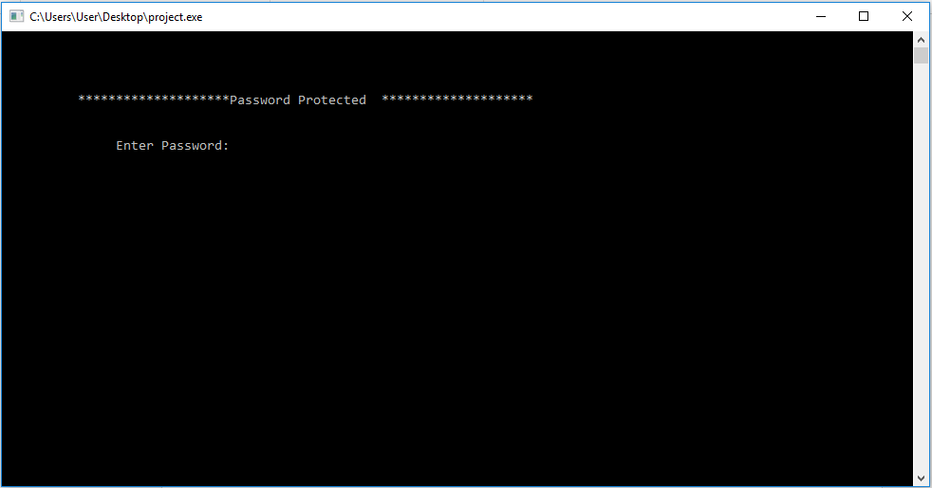

We've created the system with the password so that it can make strong protection for the user. The password for now is **"achs"**.

1. Enter password and press any keyboard key to continue.

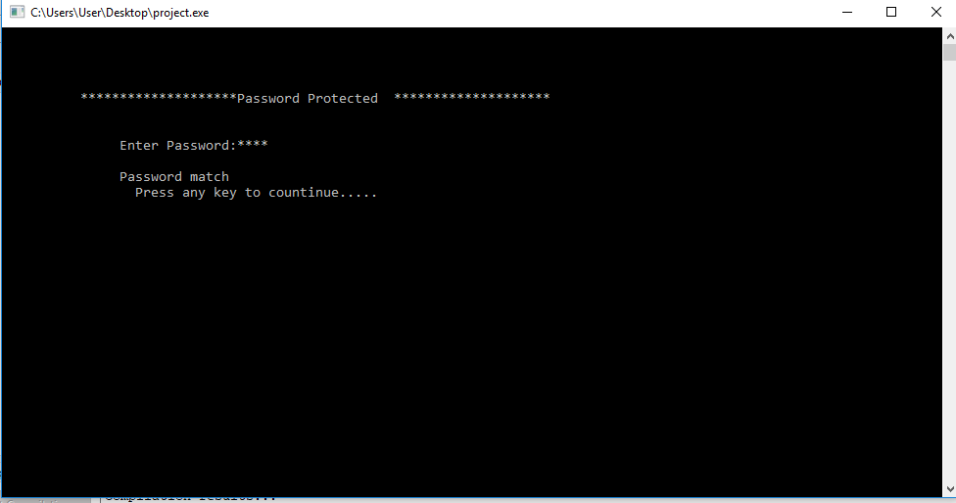

1. The screen like below will be shown which is the main menu.

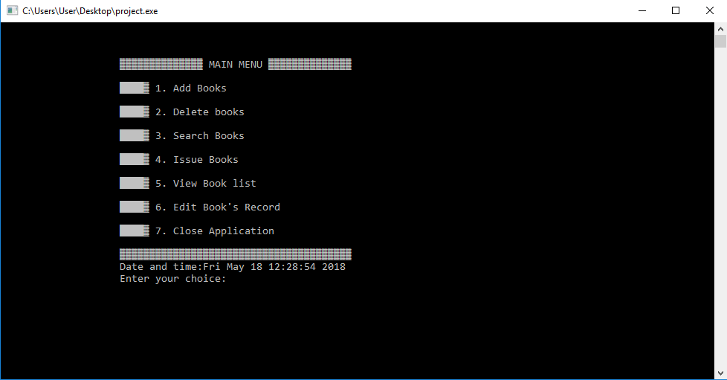

**Add New Books**

1. Add books features help in the addition of book in library. So, if we type 1 then books can be added as per the faculy.

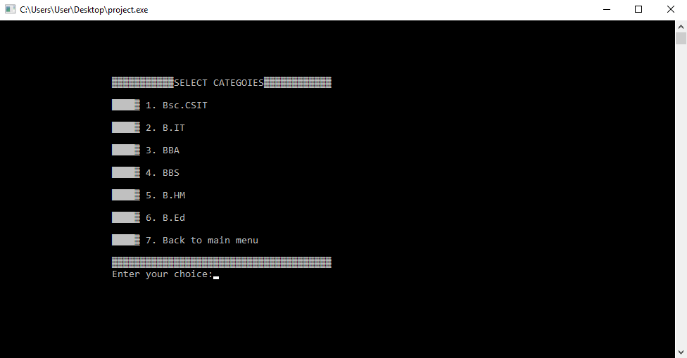

1. If we choose to add books on Bsc.CSIT then enter 1 which will show the screen as below.

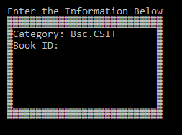

1. Now enter the information as below and if you want to enter information again then enter Y otherwise N as shown in screenshot below.

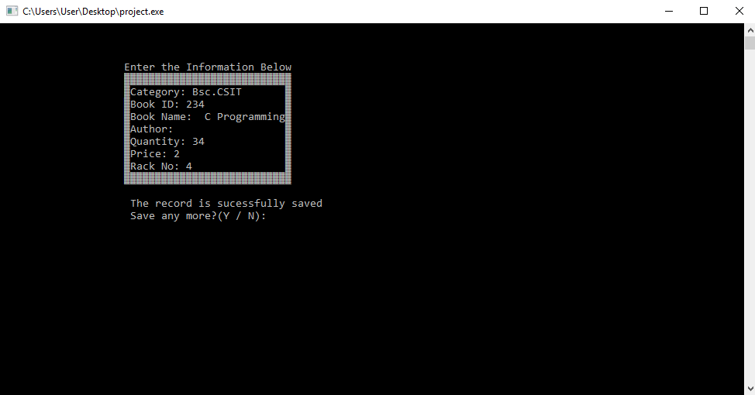

**Delete Books**

1. You'll again be redirected to homepage and if you want to delete book enter 2.

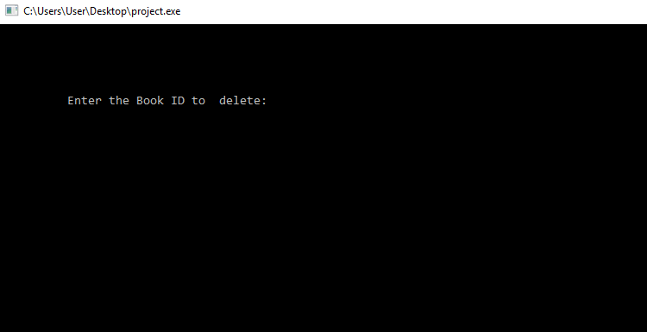

1. Enter id to delete like "234" as entered while adding in book.

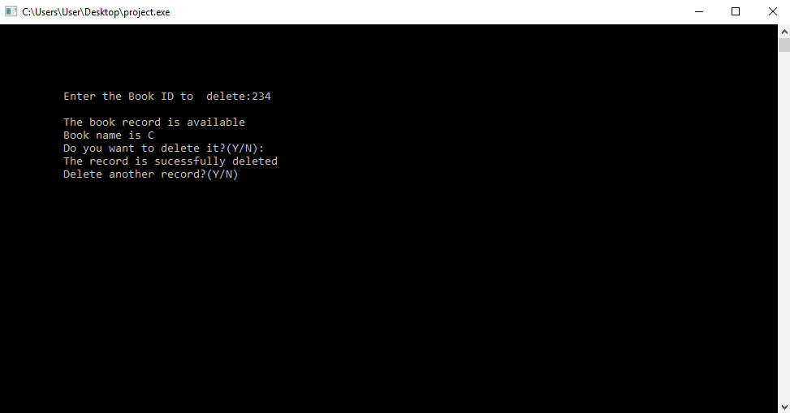

**Search Books**

1. Search the books available by entering 3 in home page menu. You've two choices to enter by name or by id by entering 1 or 2.

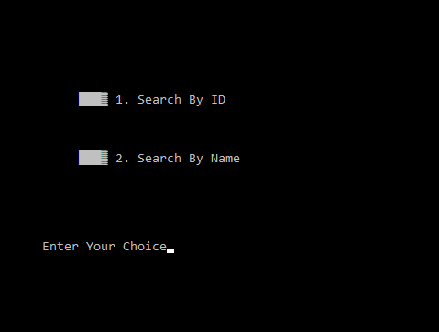

1. As per entity the information of books will be shown.

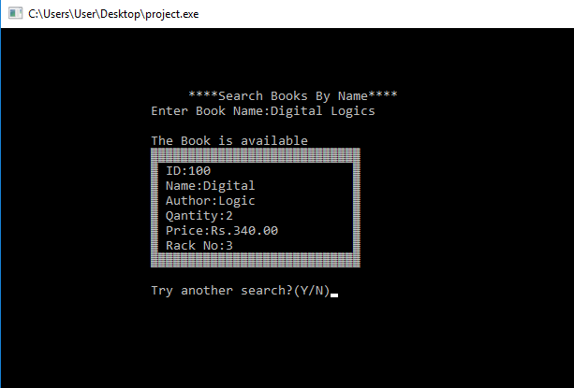

**Issue Books**

It is used if students want to take book from library for certain days.

1. Return to home and enter 4. In issue section you can see many options.

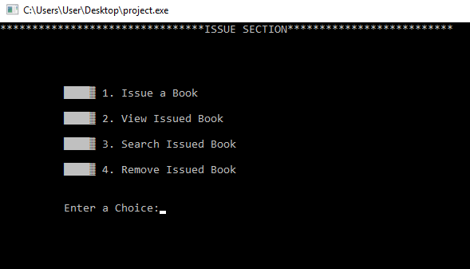

1. Issue new books as per the book id and submit name of the person who've taken the books.

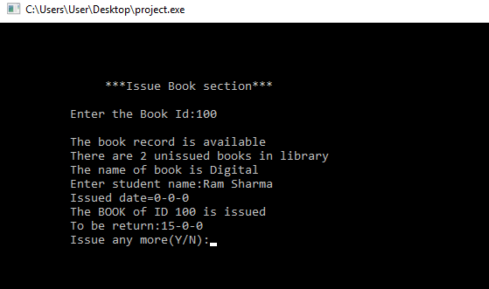

**View Book's List**

1. View the books available in the library.

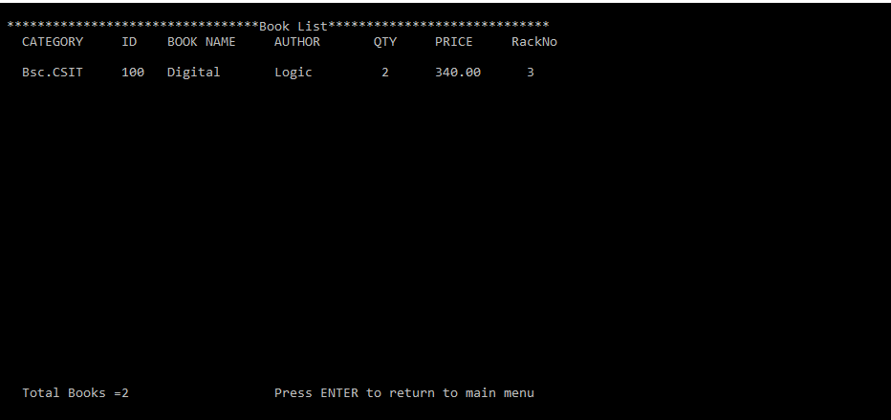

**Edit Book's Record:**

1. Edit the information of the books available in the library by entering 6. Edit the record such as Book name, rack no , Author's name, Quantity and Price.

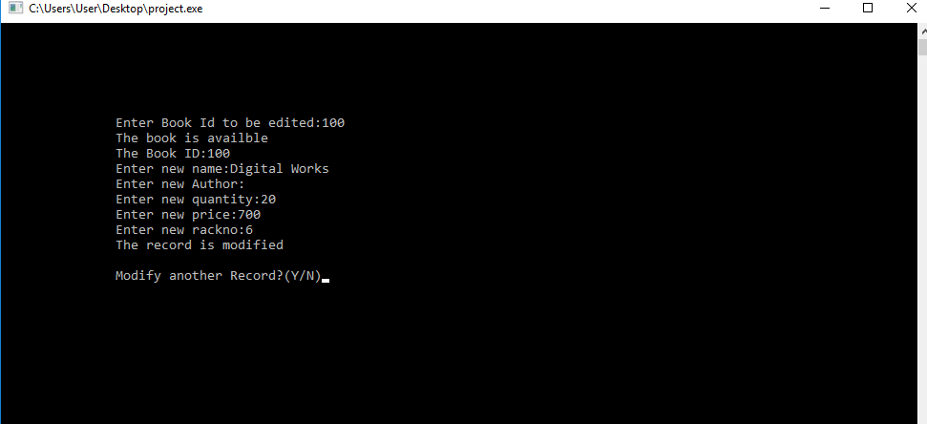

**Closing Application**

1. Close the application by entering 7 and the app will automatically exit in 3 seconds.

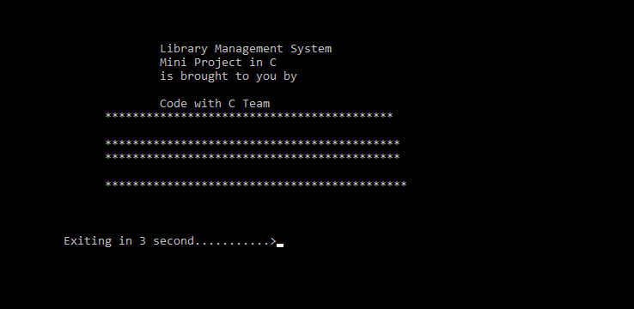

**CONCLUSION**

Finally, we've created a Library Management System, compiled and tested it successfully. We've had gain a lot of information on C Programming and had a lot of fun doing the project. This was our first programming project so bringing out the hypothesis into reality by doing such experiments helps to boost our knowledge.

Although there are some drawbacks of the system like:

* It can't perform as the professional one.
* System isn't sharply a graphical user interface. There is just use of some text, color and border.

But the programs has also some strengths like:

* It is actually a user friendly software and easy to use as instructions are appeared on the screen.
* This program has password protected system, so authorized users are allowed to access through the main system.
* One record has been saved duplicate record can't be made due to it's unique id.

All in all, what we've observed is that there is a gap between the theoretical knowledge that we learn in the class and real life implementation. This type of project helps a lot to understand the applications of programming and fill that gap between filed and syllabus. So, we hope that we'll get golden opportunity to create such project assignment in further days too.

**REFERENCES**

Books:

- Programming in ANSI C by Balguruswamy – 7th Edition

- C in a Nutshell by Prinz, Peter; Crawford, Tony (2005-12-16)

# - C Programming Language, 2nd Edition by Brian W. Kernighan, Dennis M. Ritchie

Websites:

- <https://www.geeksforgeeks.org/c-programming-language/>

- <https://www.programiz.com/c-programming>

- Udemy Course: https://www.udemy.com/learning-c-language/learn/v4/overview